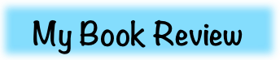copyright-oakdome.png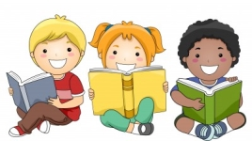

Name:

Do you recommend or not recommend this book? Why?

Book Title:

Author:

Brief Summary:

CCSS.ELA-Literacy.W.1.1 - 2.1 - 3.1